**CMPE 460 Lab Exercise Two Lab**

**UART Driver**

Joel Yuhas

Performed: January 25th, 2018

Submitted: February 1st, 2018

Lab Section: 01L2

Instructor: Louis Beato

TA: Adrian Tygart

Bao Thai

Lecture Section: 01

Professor: Ray Ptucha

**Description:**

This exercise involved writing a UART driver for the K64 Freedom board. The UART driver allows for I/O with a computer by sending messages through specific ports. Specifically, the driver can receive input form a keyboard and then output the input to the terminal.

**Screen Shot Part 1:**

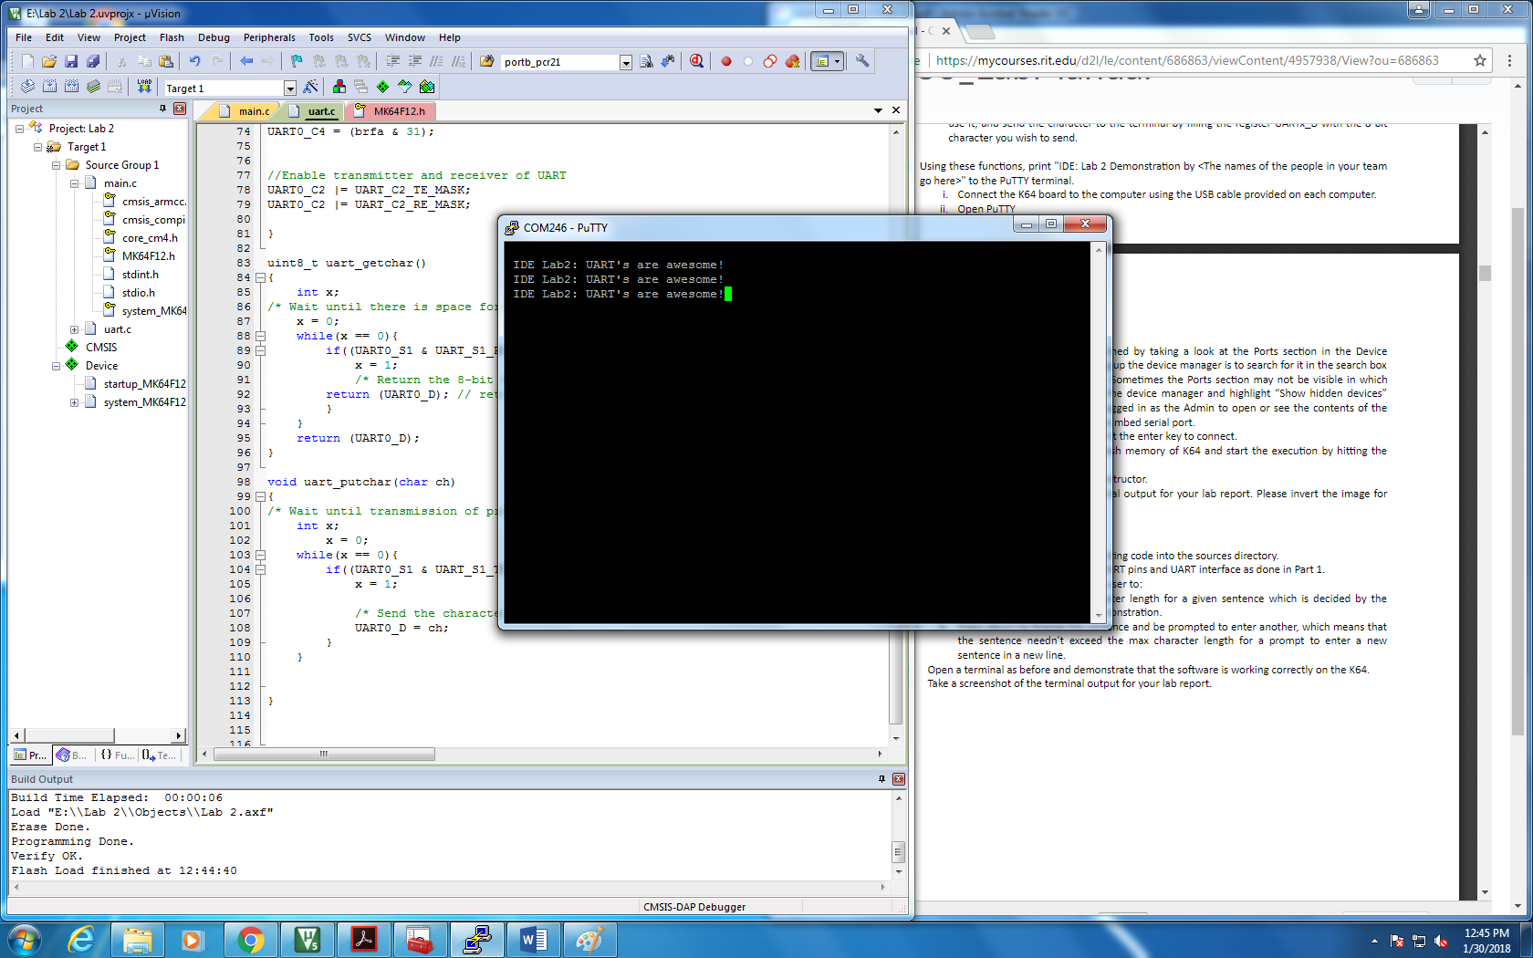

**Screen Shot Part 2:**



